Creating the Database  
CS 470 Full Stack Development II

Sergio Mateos

Southern New Hampshire University

* Part One: Creating the Question Table
  1. Graphical user interface, text

     Description automatically generatedDynamoDB
  2. Graphical user interface, application

     Description automatically generatedCreating Table

* Part Two: Adding Items and Attributes
  1. Graphical user interface, application, Teams

     Description automatically generatedCreate item.
  2. 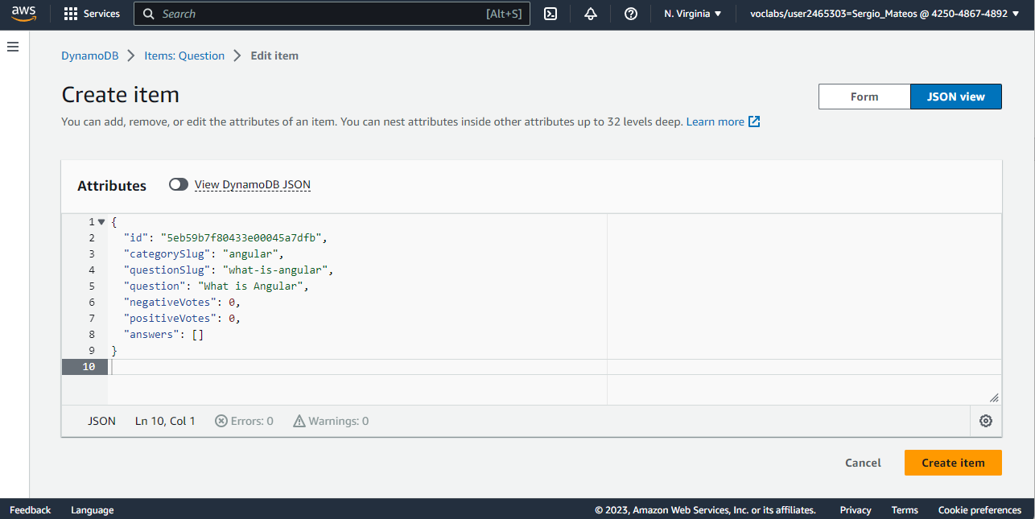GUID generated.
  3. A screenshot of a computer

     Description automatically generatedQuestion Table
* Part Three: Creating the Answer Table
  1. Graphical user interface, application

     Description automatically generatedGraphical user interface, application

     Description automatically generatedCreatin Table
  2. Graphical user interface, text, application, email

     Description automatically generatedGUID generated. **//Make sure the questionId match the idfrom Question table**
  3. A screenshot of a computer

     Description automatically generatedAnswer Table